DIE# 15027 – ATI (EXTRUDER SIDE)
Green Buggy – Long Arm – Wrap arms in cardboard
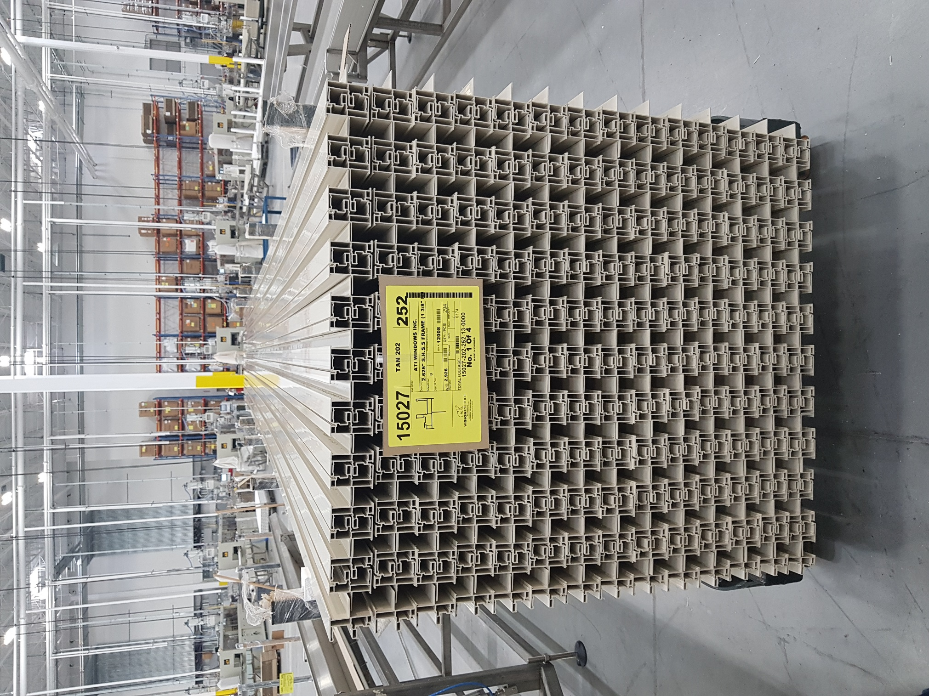
Small Foam

